目录

1 Peer Command 1

1.1 How to use peer command 1

1.1.1 login to docker container 1

1.1.2 use JavaScript 2

1.1.3 Join Channel 2

2 Chaincode Interaction 3

2.1 Peer chaincode query 3

2.2 scripts 4

3 CouchDB 5

3.1 query 5

3.2 delete 5

3.3 how does an app connect to Couchdb 5

# 1 Peer Command

## How to use peer command

### 1.1.1 login to docker container

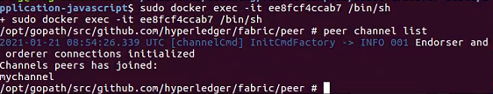

### 1.1.2 use JavaScript

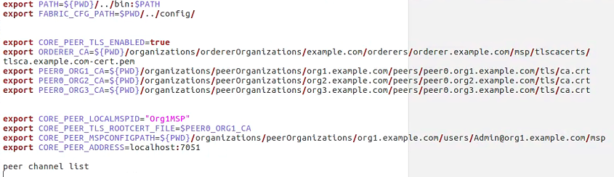

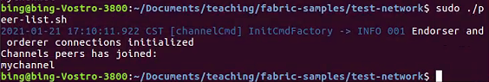

### 1.1.3 Join Channel

1. Common out the related code in createChannel.sh

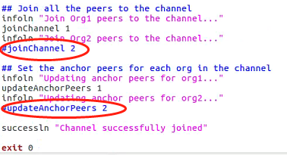

1. reset the network: sudo ./network.sh down
2. the code

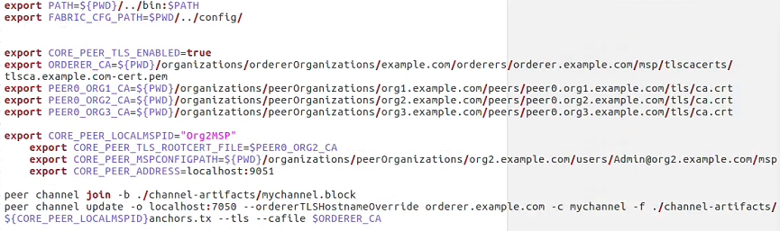

1. Result

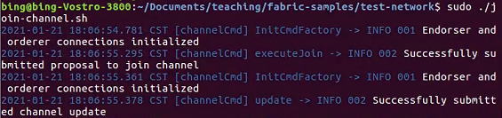

## 2 Chaincode Interaction

### 2.1 Peer chaincode query

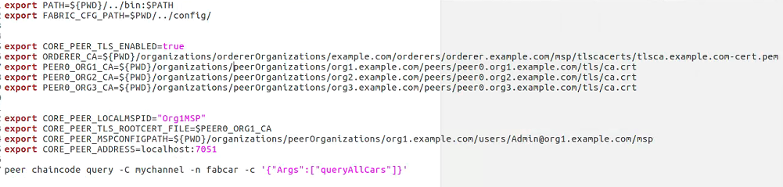

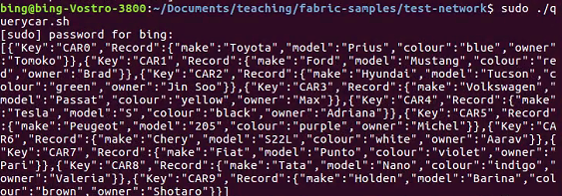





### 2.2 scripts

1. wallet add user CA

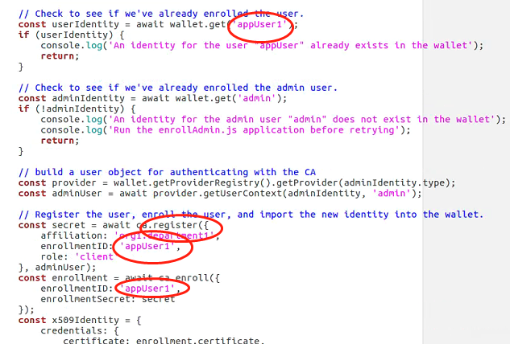

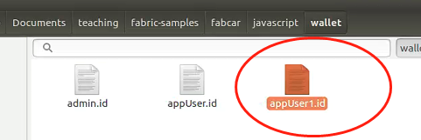

1. Javascript query

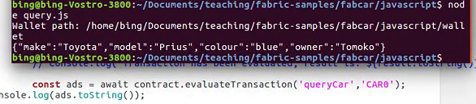

# 3 CouchDB

## 3.1 query

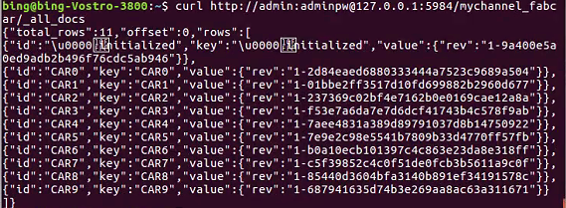

## 3.2 delete

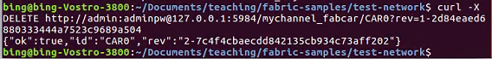

## 3.3 how does an app connect to Couchdb

